HEREFORDSHIRE WILDLIFE TRUST
Weobley and District Branch

The Wildlife of Weobley
Mike Williams
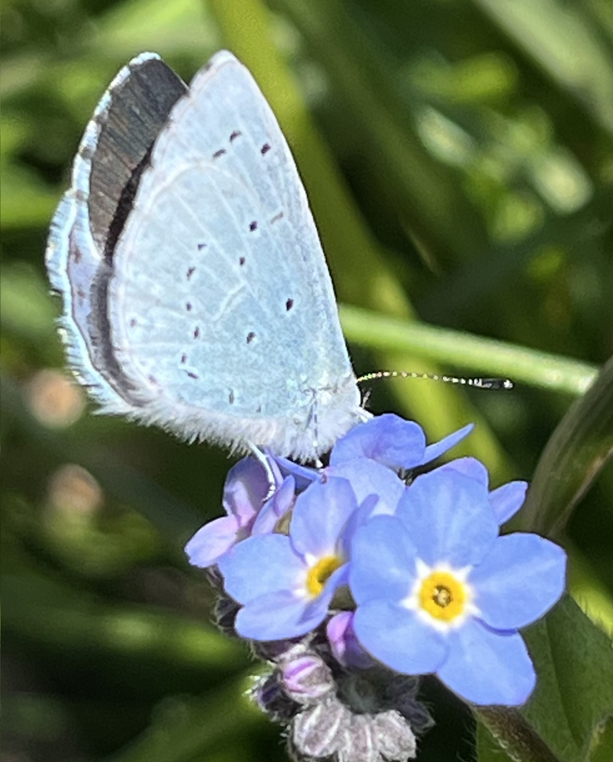
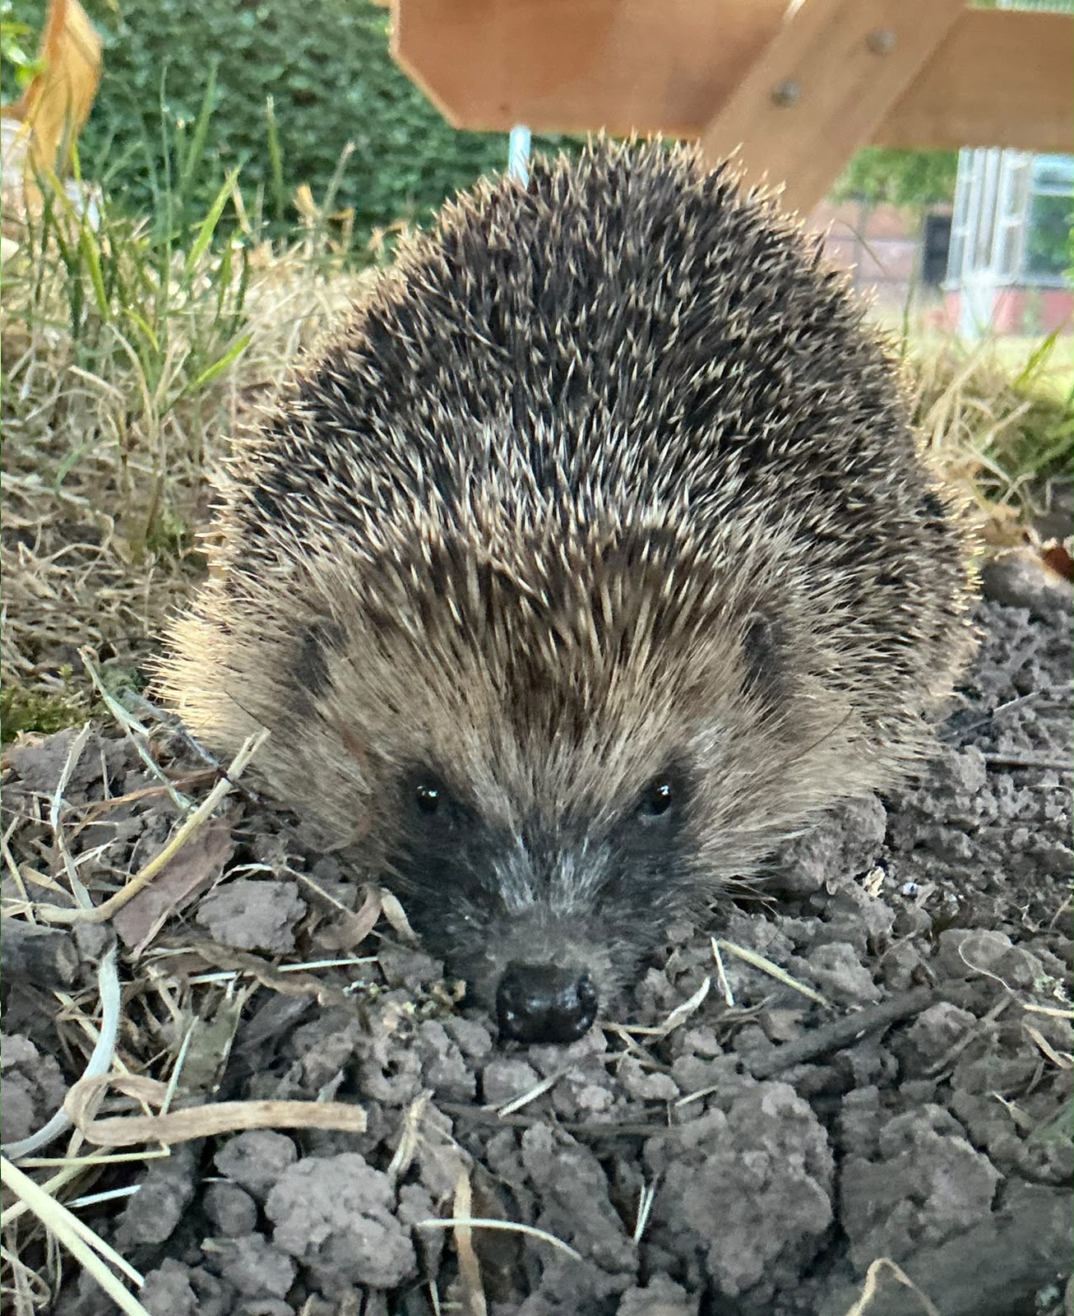

Thursday November 5th 2026

Weobley Village Hall
7.30 p.m.

Admission: HWT members £2.50, non-members/visitors £3.50

Further details from Pam Dunthorne: 07501 985756
Email: dunthopf@gmail.com

Herefordshire Wildlife Trust registered charity number 220173

